3_ Configure IP SLA tracking and path control topology.
Aim: Configure IP SLA tracking and path control topology.
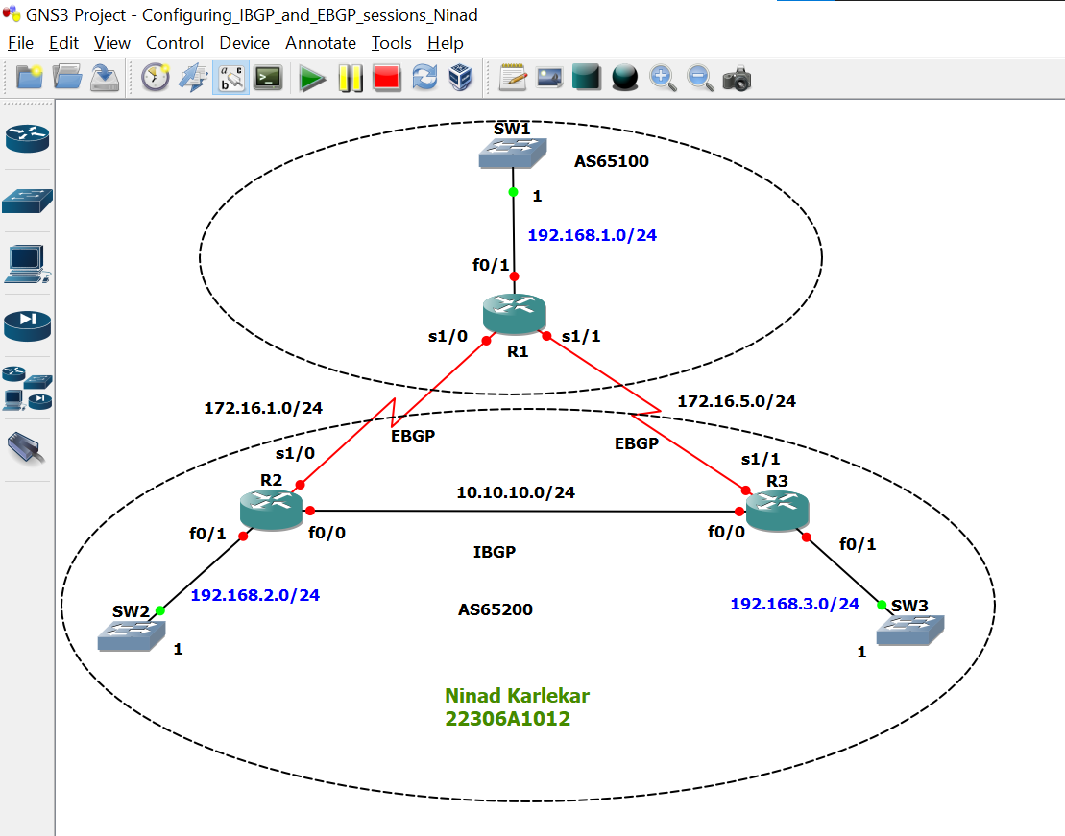
Step 1: Configure IP addresses on the given routers
R1:
R1 # conf t
R1(config) # int f0/1
R1(config-if) # ip add 192.168.1.1 255.255.255.0
R1(config-if) # no sh
R1(config-if) #
R1(config-if) # int s1/0
R1(config-if) # ip add 172.16.1.1 255.255.255.0
R1(config-if) # no sh
R1(config-if) #
R1(config-if) # int s1/1
R1(config-if) # ip add 172.16.5.1 255.255.255.0
R1(config-if) # no sh
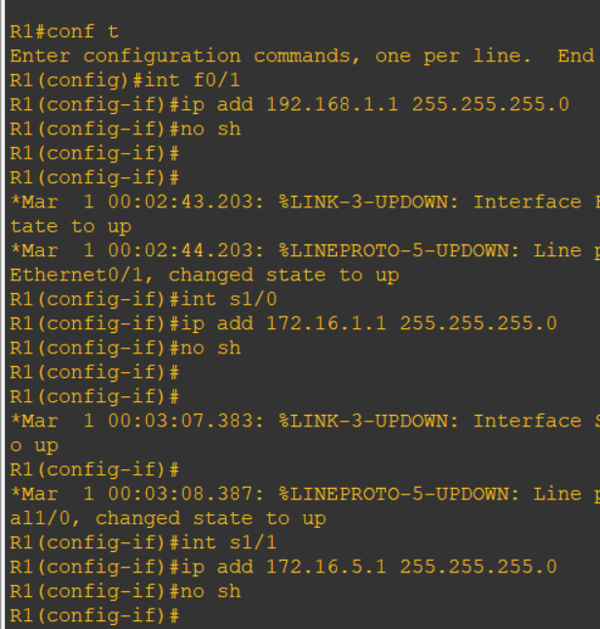

R2:
R2 # conf t
R2(config) # int f0/0
R2(config-if) # ip add 10.10.10.2 255.255.255.0
R2(config-if) # no sh
R2(config-if) #
R2(config-if) # int f0/1
R2(config-if) # ip add 192.168.2.2 255.255.255.0
R2(config-if) # no sh
R2(config-if) #
R2(config-if) # int s1/0
R2(config-if) # ip add 172.16.1.2 255.255.255.0
R2(config-if) # no sh
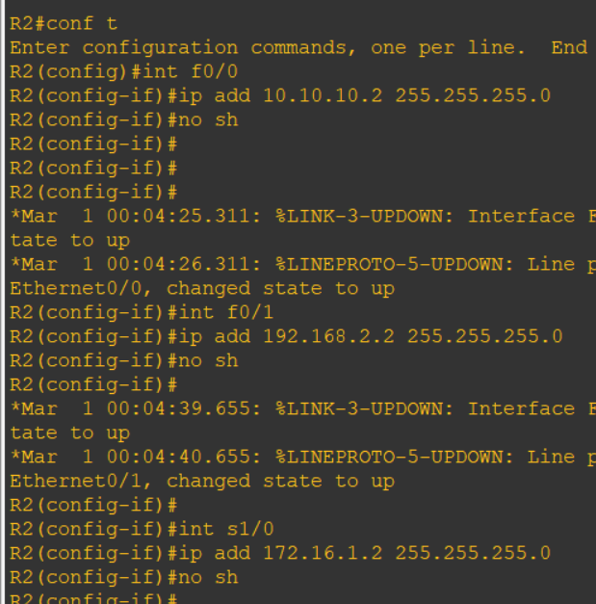

R3:
R3 # conf t
Enter configuration commands, one per line. End with CNTL/Z.
R3(config) # int f0/0
R3(config-if) # ip add 10.10.10.3 255.255.255.0
R3(config-if) # no sh
R3(config-if) #
*Mar 1 00:05:06.839: %LINK-3-UPDOWN: Interface FastEthernet0/0, changed state to up
*Mar 1 00:05:07.839: %LINEPROTO-5-UPDOWN: Line protocol on Interface FastEthernet0/0, changed state to up
R3(config-if) #
R3(config-if) # int f0/1
R3(config-if) # ip add 192.168.3.3 255.255.255.0
R3(config-if) # no sh
R3(config-if) #
*Mar 1 00:05:20.271: %LINK-3-UPDOWN: Interface FastEthernet0/1, changed state to up
*Mar 1 00:05:21.271: %LINEPROTO-5-UPDOWN: Line protocol on Interface FastEthernet0/1, changed state to up
R3(config-if) #
R3(config-if) # int s1/1
R3(config-if) # ip add 172.16.5.3 255.255.255.0
R3(config-if) # no sh

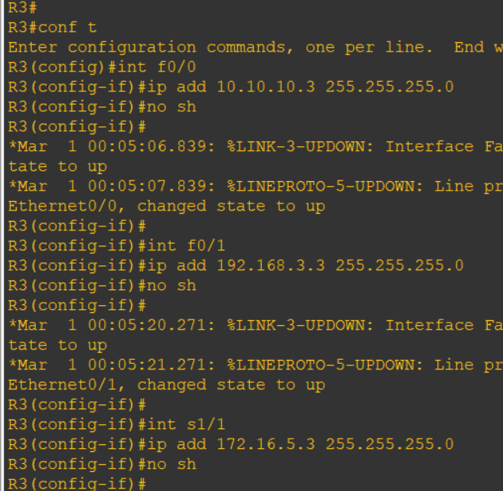

On all routers:
do sh ip int br | include up
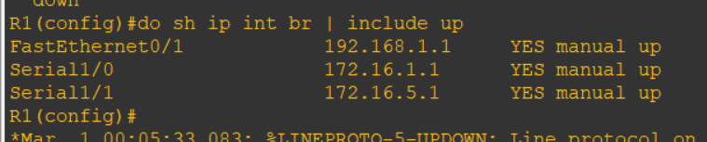

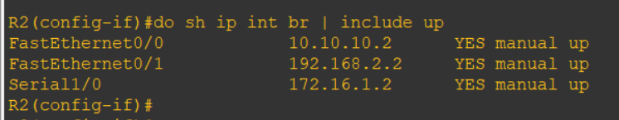

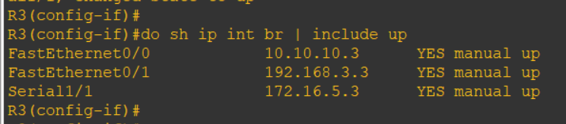

Step 2: Configure IRP in autonomous system 65200

R2:
R2(config-if) # router ospf 1
R2(config-router) # network 10.10.10.0 0.0.0.255 area 0
R2(config-router) # network 192.168.2.0 0.0.0.255 area 1
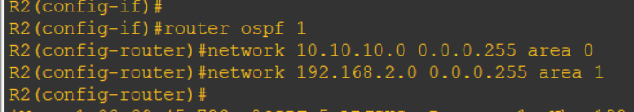

R3:
R3(config-if) # router ospf 1
R3(config-router) # network 10.10.10.0 0.0.0.255 area 0
R3(config-router) # network 192.168.3.0 0.0.0.255 area 2
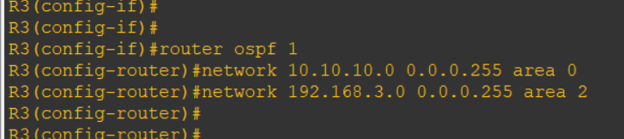

do ping 192.168.2.2
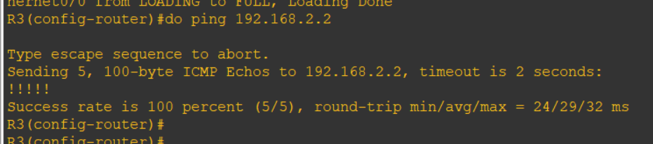

Step 3: IBGP & EBGP configuration
R1:
R1(config) # router bgp 65100
R1(config-router) # network 192.168.1.0
R1(config-router) # network 172.16.1.0 mask 255.255.255.0
R1(config-router) # network 172.16.5.0 mask 255.255.255.0
R1(config-router) # neighbor 172.16.1.2 remote-as 65200
R1(config-router) # neighbor 172.16.5.3 remote-as 65200
R1(config-router) # do sh ip route
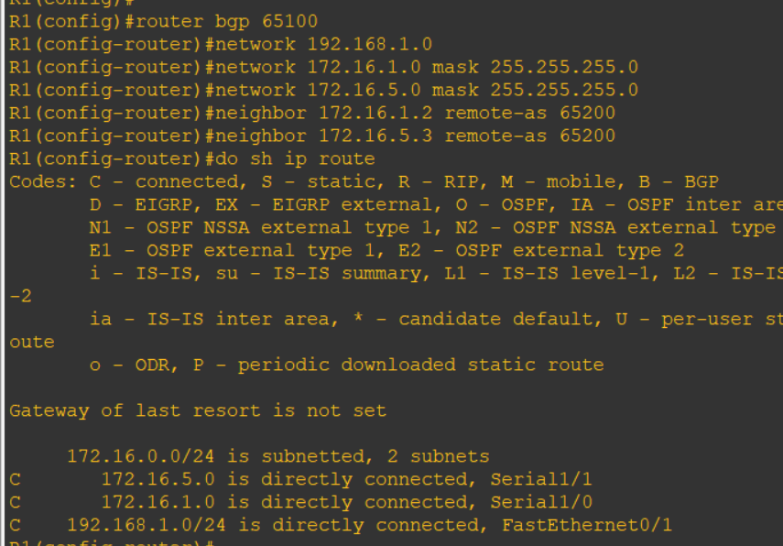

R2:
R2(config-router) # router bgp 65200
R2(config-router) # redistribute ospf 1
R2(config-router) # network 172.16.1.0 mask 255.255.255.0
R2(config-router) # neighbor 172.16.1.1 remote-as 65100
R2(config-router) # neighbor 10.10.10.3 remote-as 65200
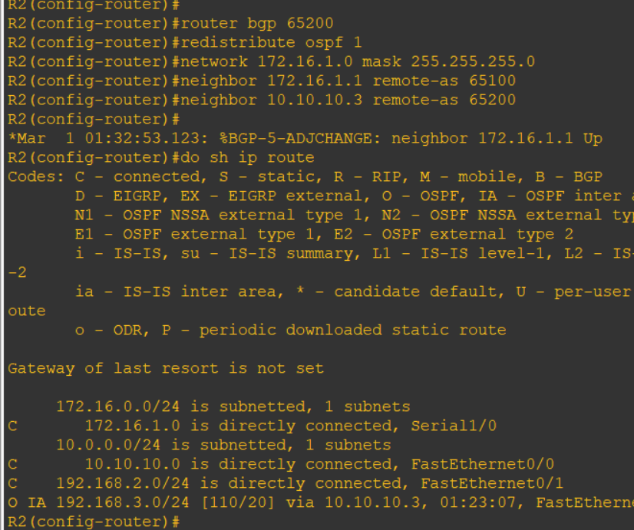

R3:

R3(config-router) #
R3(config-router) # router bgp 65200
R3(config-router) # redistribute ospf 1
R3(config-router) # network 172.16.5.0 mask 255.255.255.0
R3(config-router) # neighbor 172.16.5.1 remote-as 65100
R3(config-router) # neighbor 10.10.10.2 remote-as 65200
R3(config-router) # do sh ip route
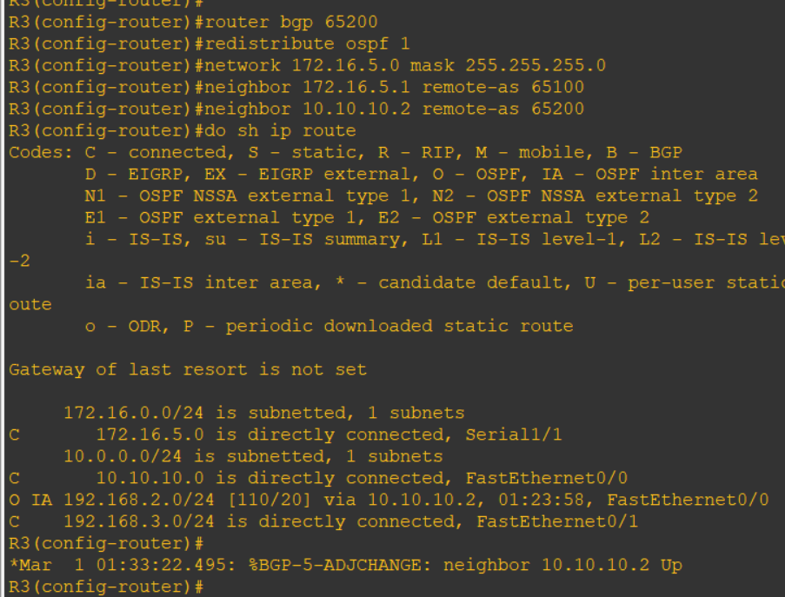

R1:
do ping 192.168.3.3
do ping 192.168.2.2
